Pentecostal/Charismatic Churches of North America
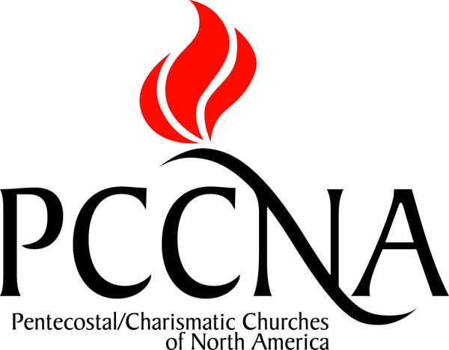

CONTACT:
Pentecostal/Charismatic Churches of North America
Chairman Jeff Farmer
Phone: 253.446.6475
Email: info@pccna.org
Web: pccna.org

FOR IMMEDIATE RELEASE – February 29, 2012

Pentecostals Resolve to Widen their Borders

The Pentecostal/Charismatic Churches of North America (PCCNA) is saying to Mexican Spirit-filled leaders, “Partner with us in mission and fellowship!” Since their inception in 1994, the PCCNA has desired that all North American Pentecostals and Charismatics unite to demonstrate unity in the power of the Spirit. Economic issues and communication barriers have prevented the inclusion of our neighbors to the south. But no more! At their February 29 meeting in Virginia Beach, Virginia PCCNA decided to become very intentional in reaching out to Mexico. The action begins the most significant expansion of the PCCNA since its inception and creates the largest ever Pentecostal/Charismatic consortium on the continent. Since 2000, Protestant numbers in Mexico, mostly Pentecostal, have multiplied four times. This great growth is evidenced, for example, by one local church, said to have over 120,000 members.
The PCCNA agreed to undergird and broaden their efforts with World Vision US to end malaria in our lifetime through the distribution of $6 insecticide-treated bed nets. Nineteen PCCNA groups have enrolled in what is considered World Vision’s largest consortium of cooperative churches. Ninety-one percent of all malaria deaths occur in Africa of which eighty-five percent are children ages five and under…over 1,500 per day. Many parents do not name their children until they reach the age of five. The PCCNA War on Malaria project has prompted World Vision Canada to join the effort so as to include eager Pentecostal/Charismatic organizations and churches in Canada. The PCCNA leaders accepted the challenge of gathering a thousand churches to the drive by World Malaria Day, April 25.
In keeping with the Widening the Witness theme of the gathering, a commission was charged to study how a newly conceived North American Pentecostal Press Association could advance the vision of Pentecostal/Charismatic movements across the continent.
David Ferguson, founder of Intimate Life Ministries and leader of the Next Gen Imperative reinforced the importance of emerging Pentecostal/Charismatic leaders. The PCCNA is committed to pass a Spirit-empowered faith to the next generation so they can know and live the unshakable truths of the gospel through a four step process: Explore, Embrace, Experience and Express.
The two days of meetings were characterized by an atmosphere charged with passion to fulfill the strategic vision of Demonstrating Unity in the Power of the Spirit.
The PCCNA was formed through The Memphis Miracle in 1994 when white and African-American Pentecostals united in a commitment to pray, work, and love together. The PCCNA is now a cooperative fellowship of thirty-three Pentecostal/Charismatic denominations and associations in North America representing over 90 million constituents across the world.
- Clyde M. Hughes, International Pentecostal Press Association

